Monday
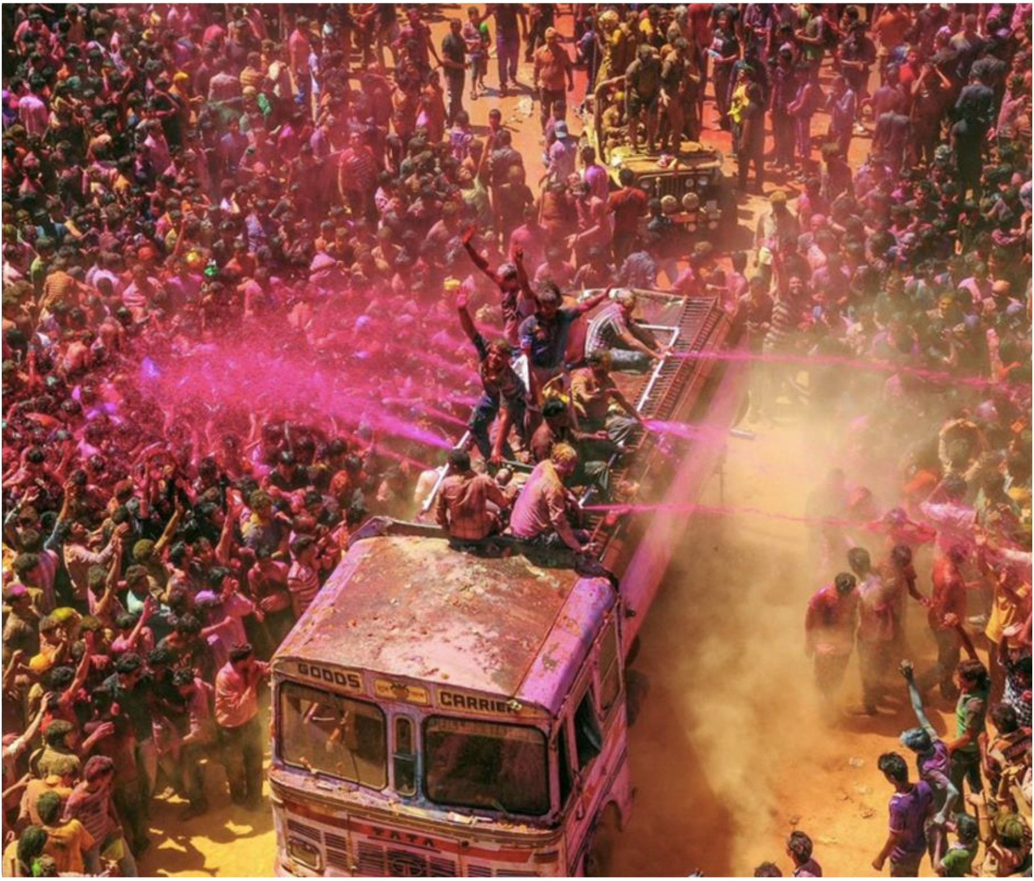

Story starter! Read the text carefully

It was the day they'd all been waiting for. As the colours started to flow, the whole town started to celebrate.
This was a tradition that had been followed, without fail, for hundreds of years. The crowd began to swell even more, cooled by the jet streams of paint that filled the air. The festival of colours was truly underway...

Question time!

► Why do you think the people in the photograph have gathered?
► What is a 'tradition'? Are there any traditions that you adhere to?
► Do you know anything about the festival of colours?
► Why do people celebrate the festival in this way?
► Would you like to be there?
► What would it feel like to be standing in the crowd or on top of the bus?
► Where in the world do you think this is?

Sentence challenge!
Using your senses is often an effective way to describe a scene to the reader.
Can you use all of your 5 senses to describe what it would be like to be there in the picture?
Tuesday

Sick sentences!

These sentences are 'sick' and need help to get better. Can you help?
► It was a hot day.
► A crowd had gathered.
► Some people sprayed paint.
► It was pink.
► The crowd were noisy.

Perfect picture!

Can you draw a picture of a tradition that you follow in your school or home?

Wednesday and Thursday

Creative writing challenge! Think about a tradition at you celebrate at home or school.

You are to write a short description of this holiday, describing the activities you carry out etc.

You have two days to do this so you can concentrate on planning your ideas and starting your first draft on Wednesday. On Thursday, complete your draft and carefully proof-read your writing.

Proof-read your story for punctuation and check for the following features:
- Adverbial phrases to order events, especially at the start of paragraphs.
- The use of adverbs
- A wide variety of adjectives, including the use of expanded noun phrases.

Friday

Grammar Activity

