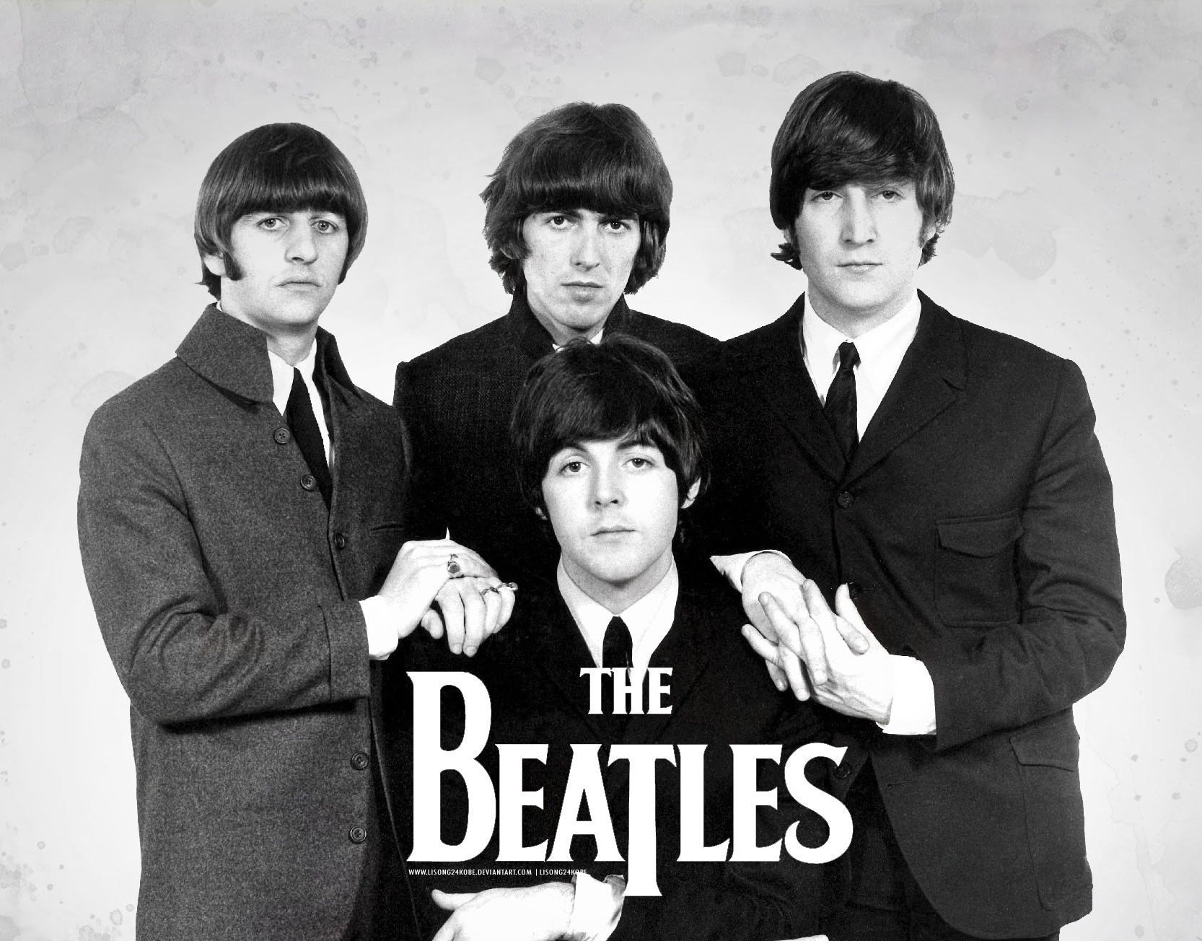
Y5H Curriculum Newsletter for Autumn 1
Our topic this term will be ‘Rockstars.’
Children will learn all about the History of music, including a study of a historical or current singer/band. We shall learn about different genres of music and appreciate these through listening carefully to piece of music and songs during our Morning Job.
Important things to note for Year 5:
Our PE days are on a Thursday and Friday. Please make sure your child has suitable PE kit in school on these days. Long hair must also be tied back and all jewellery removed. Also make sure children have suitable outdoor PE kit and footwear for PE. Our PE topics for this half term are football and hockey.
Homework: Most children are expected to know all of their times tables rapidly by Year 5. To maintain this instant recall of times tables, they will be tested on a Friday each week.
Other homework is handed out on a Friday and should be returned the following Wednesday.
Remember to fill in your reading diary at home so you can move along the reading race track in our reading corner! Bronze award is awarded after your first fifty home reads!
In maths we are learning:
- To read, write, compare and order 5 digit numbers.
- To use written addition to add two 4-digit numbers.
- To add and subtract two digit numbers mentally.
- To understand place value in decimal numbers and apply these to a range of calculations.
- To revise the 12-hour clock to the 24 hour clock.
- To subtract 3 and 4 digit numbers using a written method.
- To find equivalent fractions and reduce them to their simplest form.
- To use a protractor to measure and draw different angles.

In literacy we are learning:
- To write a rap, considering the different poetic devices. Children may bring in a ‘rap cap’ to school each day to wear during literacy, to make them look ‘Hip Hop!’
- To write a biography of either a band or singer of our choice, after we have researched well about their background.
- To write a detailed set of instructions. This will link with our DT project of making a musical instrument.

In other subject areas we are learning:
Science: We will learn about the topic Separating Mixtures, using the skills of sieving, filtering and evaporating to separate solids, liquids and gases.

Art and DT: In DT we will research, design and make our own musical instrument. This topic will run throughout the whole of the half term to ensure that detail is added during the planning and design stages.
- ICT: Children will continue developing their coding skills from Y4 and research for our topic during computing lessons.
- Music: Children will follow the Charanga scheme and cover a unit around music appreciation – Livin’ on a prayer. We will also study how different instruments make sound, to aid our understanding during our DT project.

- RE: Children will learn about ‘The Five Pillars of Islam.’
Important dates:
- 24.09.18 – Parents Workshop – Meet the Teacher 2:15pm
- 01.10.18 – Toast Week
- 23.10.18 – Individual Photographs
- 25.10.18 – School Disco
- 26.10.18 – Break up for half term 3:15pm

I have an open door policy, so any questions, please don’t hesitate to come and see me. I look forward to meeting you all and working with your children this year. Mrs Hales






