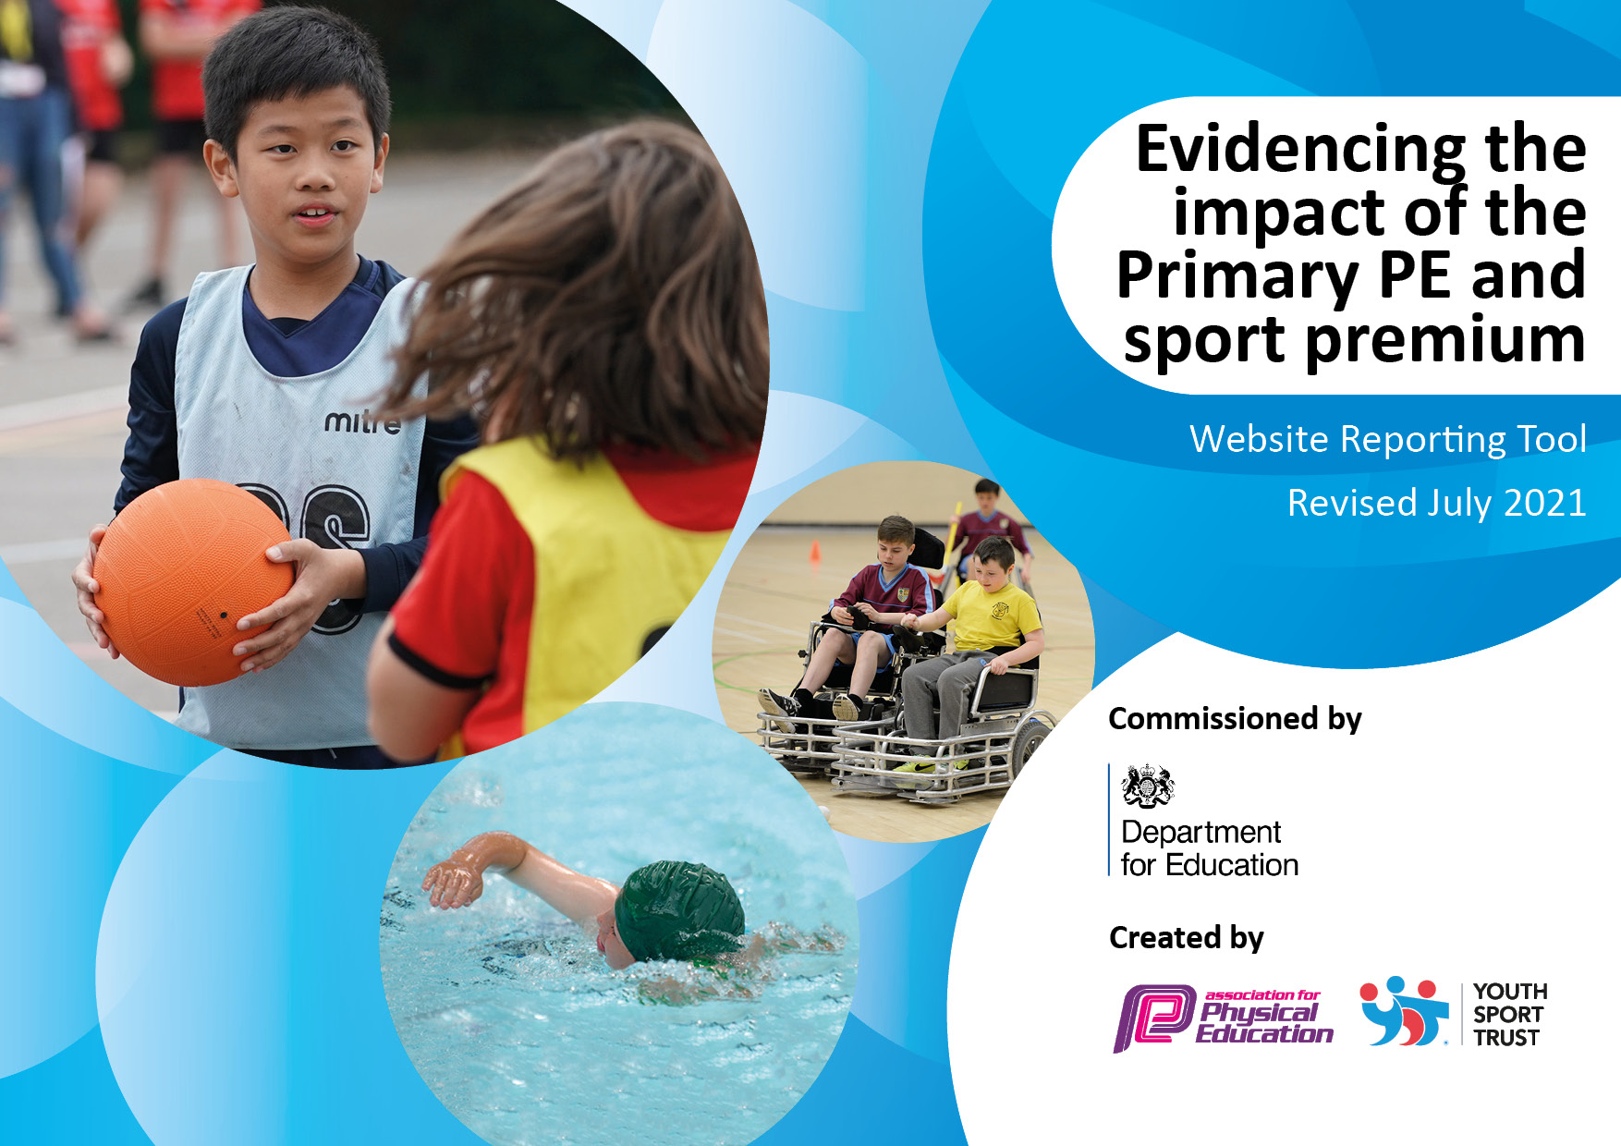
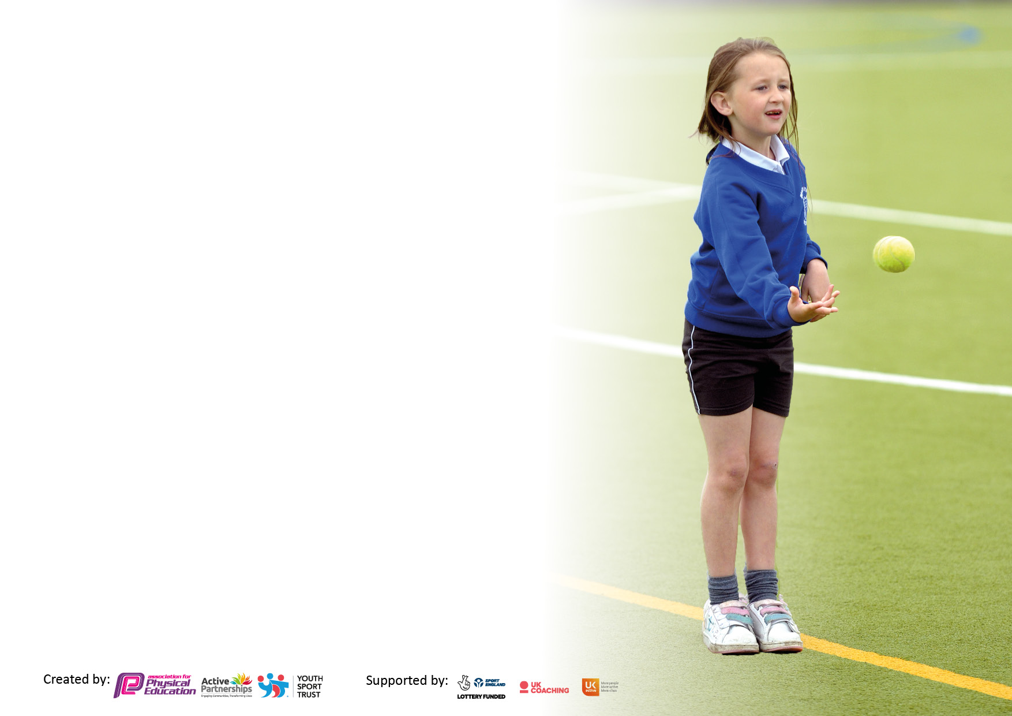

It is important that your grant is used effectively and based on school need. The Education Inspection Framework makes clear there will be a focus on ‘whether leaders and those responsible for governors all understand their respective roles and perform these in a way that enhances the effectiveness of the school’.

Under the Quality of Education Ofsted inspectors consider:
Intent - Curriculum design, coverage and appropriateness
Implementation - Curriculum delivery, Teaching (pedagogy) and Assessment
Impact - Attainment and progress

To assist schools with common transferable language this template has been developed to utilise the same three headings which should make your plans easily transferable between working documents.

Schools must use the funding to make additional and sustainable improvements to the quality of Physical Education, School Sport and Physical Activity (PESSPA) they offer. This means that you should use the Primary PE and sport premium to:

- Develop or add to the PESSPA activities that your school already offer
- Build capacity and capability within the school to ensure that improvements made now will benefit pupils joining the school in future years
- The Primary PE and sport premium should not be used to fund capital spend projects; the school’s budget should fund these.

Pleasevisitgov.ukfortherevisedDfEguidanceincludingthe5keyindicatorsacrosswhichschoolsshoulddemonstrate animprovement.Thisdocumentwillhelpyoutoreviewyourprovisionandtoreportyourspend.DfEencouragesschools to use this template as an effective way of meeting the reporting requirements of the Primary PE and sport premium.

We recommend you start by reflecting on the impact of current provision and reviewing the previous spend.

Schools are required to publish details of how they spend this funding, including any under-spend from 2019/2020, as well as on the impact it has on pupils’ PE and sport participation and attainment. All funding must be spent by 31st July 2022.

We recommend regularly updating the table and publishing it on your website throughout the year. This evidences your ongoing self-evaluation of how you are using the funding to secure maximum, sustainable impact. Final copy must be posted on your website by the end of the academic year and no later than the 31st July 2021. To see an example of how to complete the table please click HERE.
Created by: Supported by:

Details with regard to funding
Please complete the table below.

Total amount carried over from 2019/20 | £0
Total amount allocated for 2020/21 | £19050
How much (if any) do you intend to carry over from this total fund into 2021/22? | £0
Total amount allocated for 2021/22 | £19030
Total amount of funding for 2021/22. To be spent and reported on by 31st July 2022. | £19030
Swimming Data
Please report on your Swimming Data below.

Meeting national curriculum requirements for swimming and water safety.  N.B. Complete this section to your best ability. For example you might have practised safe self-rescue techniques on dry land which you can then transfer to the pool when school swimming restarts.  Due to exceptional circumstances priority should be given to ensuring that pupils can perform safe self rescue even if they do not fully meet the first two requirements of the NC programme of study | 81%
What percentage of your current Year 6 cohort swim competently, confidently and proficiently over a distance of at least 25 metres?  N.B. Even though your pupils may swim in another year please report on their attainment on leaving primary school at the end of the summer term 2022.  Please see note above | 81%
What percentage of your current Year 6 cohort use a range of strokes effectively [for example, front crawl, backstroke and breaststroke]?  Please see note above | 81%
What percentage of your current Year 6 cohort perform safe self-rescue in different water-based situations? | 100%
Schools can choose to use the Primary PE and sport premium to provide additional provision for swimming but this must be for activity over and above the national curriculum requirements. Have you used it in this way? | Yes/No

Action Plan and Budget Tracking
Capture your intended annual spend against the 5 key indicators. Clarify the success criteria and evidence of impact that you intend to measure to evaluate for pupils today and for the future.

Academic Year: 2021/2022 | Total fund allocated:£19030 | Date Updated: July 2022
Key indicator 1: The engagement of all pupils in regular physical activity – Chief Medical Officers guidelines recommend that primary school pupils undertake at least 30 minutes of physical activity a day in school |  |  |  | Percentage of total allocation:
 |  |  |  | 24%
Intent | Implementation |  | Impact
Your school focus should be clear what you want the pupils to know and be able to do and about  what they need to learn and to  consolidate through practice: | Make sure your actions to achieve are linked to your intentions: | Funding allocated:  £4674 | Evidence of impact: what do pupils now know and what can they now do? What has changed?: | Sustainability and suggested next steps:
Improvements in participation within the curriculum and extracurricular in order to be active and broaden range of skills. | - Provide a variety of sports clubs after school to all pupils…  RUCST – football, basketball and multi-sports for KS2 Rugby Tots – multi –sports for KS1 and EYFS  Dance for KS2 | £4564 *Additional £436 school funded (£5000) | - A range of children including PP have attended clubs – registers were taken and there was a rotation of children each term. | - Continue to offer a range of activities at lunchtime/ after school – with RUCST being inclusive of all children within their activities at lunch. Tuesday to Friday all year round – including football team training.
To nurture a lifelong commitment to achieving a healthy lifestyle through healthy eating and exercise. | - Purchasing of new playtime/sport equipment, with varying activities to encourage active breaks and lunchtimes.  - Encouraging healthy eating at lunchtimes and in PSHCE lessons/assemblies. |  | - RUCST have been present at lunchtimes each day to engage children in competitive games/activities. More children now engaging in active play and using the equipment more regularly.  - Children only having fruit or a healthy snack at break times. | - Children to be encouraged to participate in fitness games and challenges during breaks and lunchtimes to promote healthy lifestyles.
Empower pupils to promote and engage others in active games. | - Y5 cohort to participate in the Joy of Moving programme for 6 weeks about healthy and active lifestyles – run by RUCST.  - Y6 pupils to engage in play leaders’ course (6 weekly sessions) |  | - Y5 now understand the importance of physical activity, a healthy body and mind, the Eatwell Guide, meal planning, hydration and the joy of moving.  - Leaders empower and inspire others. This is reflected in pupil voice activity. | - Next Y5 cohort to participate in the Joy of Moving programme.  - Next Y6 cohort to participate in the play leaders’ course.
Key indicator 2: The profile of PESSPA being raised across the school as a tool for whole school improvement |  |  |  | Percentage of total allocation:
 |  |  |  | 8.4%
Intent | Implementation |  | Impact
Your school focus should be clear what you want the pupils to know and be able to do and about  what they need to learn and to  consolidate through practice: | Make sure your actions to achieve are linked to your intentions: | Funding allocated:  £1600 | Evidence of impact: what do pupils now know and what can they now do? What has changed?: | Sustainability and suggested next steps:
- For all staff (including TAs and sports coach at lunchtimes) to continue to promote PE and an active lifestyle. | - Staff to lead by example in the correct kit and footwear for participation in PE.  - Source spare kit for those children who do not have suitable clothing in which to participate. | £100 | - An improvement in children having the correct PE kit across school (a noticeable difference seen as children have been coming to school in kit since COVID19). Need to reinforce this for September. | - Children to be encouraged to participate in fitness games and challenges during breaks and lunchtimes to promote healthy lifestyles.
- To maintain a high profile of sports in our school (Sport Relief, Olympics, World Cup, sport personalities, sports day, parent sporting events) | - All sports to be celebrated and talked about equally – also ensuring equality across girls and boys.  - The school website includes a sport section and is regularly updated with events and achievements – including achievements out of school  - Scheduled sports day events in each key stage (all children to participate in each event/activity).  - Whole school participation in PE related events – Joy of Moving festival etc. |  | - The website reflects the range of sport undertaken in school.  - RUCST have helped to promote PE and the importance of physical activity throughout school during PE lessons, in assemblies and through the JOM programme. | - A school sport calendar to be created which includes a whole school series of sporting events – including RUCST events, national and world events. Make this visible in school.  - More festivals are scheduled for the next calendar year so outcomes will be shared with parents on dojo and on the school website.
- To recognise all pupils, including the less academic pupils who have an exceptional attitude towards PE and/or have a specific skill. | - Participation and achievements in out of school sport activities to be celebrated in assemblies and on class dojo.  - Children’s sporting abilities to be recognised by teachers and celebrated in special mentions- ensuring children who are deemed ‘less sporty’ are recognised for their efforts in PE |  | - Children are eager to share out of school sporting certificates, trophies and achievements with their classes regularly- these are then spoken about and celebrated further in KS’s celebration assembly. | - Continue to maintain the high profile of sport across school.
- To raise aspirations of all pupils by providing opportunities to observe live sporting events and sports people in action. | - Take advantage of the ticket allocation provided by RUCST.  - Observe live theatre production – dance focus – Rotherham College  - Book dance workshops for whole school.  - RUCST and other sourced, local sports people – aspirational talks with pupils. | £500 transport  £200 transport  £800 | - Opportunities allow pupils to see professionals in action and are inspired to take part in related activities. | - Continue to make links with partners in the community so that pupils are immersed in sport and physical activity.

Key indicator 3: Increased confidence, knowledge and skills of all staff in teaching PE and sport |  |  |  | Percentage of total allocation:
 |  |  |  | 41.29 %
Intent | Implementation |  | Impact
Your school focus should be clear | Make sure your actions to | Funding | Evidence of impact: what do | Sustainability and suggested
what you want the pupils to know | achieve are linked to your | allocated: | pupils now know and what | next steps:
and be able to do and about | intentions: | £7856 | can they now do? What has
what they need to learn and to |  |  | changed?:
consolidate through practice:
- To increase CPD opportunities for both current and new staff, in line with the new iMoves scheme of work. | - Funded PE specialists (RUCST) to support practitioners in improving and widening their skill sets and confidence in the delivery of physical activity, quality PE lessons and model good practice to staff. (Premier League Primary Stars – 6 x 1 hour sessions) Staff CPD and P.E network (3 sessions)  - Imoves subscription | £7020  £836 | - Practitioners delivering high quality PE – with evident progression throughout school.  - Upskilling of practitioners. | - PE specialists to continue to train staff in order to secure sustainability beyond access to sport’s funding.  - RUCST to give staff CPD sessions (total of 3 for the year) – CC to devise a questionnaire to gain an understanding of individual development needs.  - New scheme of work discussed with staff and all knowledge organisers to be updated in line with iMoves.
- To continue supporting practitioners in order to gain confidence, improve their knowledge and home their skill set. | - Staff to observe either RUCST (sport coaches), CC or JT (PE leaders) in good practise, lesson structure and to broaden their understanding of unfamiliar sports. |  | - Improved attitude towards learning and participation within physical activity.  - Upskilling of practitioners.
Key indicator 4: Broader experience of a range of sports and activities offered to all pupils |  |  |  | Percentage of total allocation:
 |  |  |  | 18.44%
Intent | Implementation |  | Impact
Your school focus should be clear | Make sure your actions to | Funding | Evidence of impact: what do | Sustainability and suggested
what you want the pupils to know | achieve are linked to your | allocated:  £3510 | pupils now know and what | next steps:
and be able to do and about | intentions: |  | can they now do? What has
what they need to learn and to |  |  | changed?:
consolidate through practice:
- To continue to increase the number of girls who participate in sports at school. | - Provide a variety of sports clubs after school to all pupils across both Key stages. Provide a ‘girls only’ football club for those less confident playing sports with boys. |  | - More girls attending after school clubs. | - Attend girls only festivals with the RUCST calendar.
- To continue to provide a variety of sports clubs and lunchtime activities to promote a love for sport and increase levels of activity among all pupils. | - Provide a variety of sports clubs after school to all pupils across both Key stages. Provide a ‘girls only’ football club for those less confident playing sports with boys.  - RUCST present at lunch to promote active lifestyles and will engage children in supervised games e.g. cricket and football.  - Extra-curricular clubs set up in advance of each half term. | £3510 | - A range of children are attending clubs – registers will be taken. Rotation of children every 7 weeks. Multi-sports, Football, Dance, Rugby Tots.  - Pupil voice reflects increased enjoyment and awareness of being active.  - More children will voluntarily engage in sports and will play with sport equipment at breaks and lunchtimes.  - RUCST getting children engaged in a range of activities during active lunchtimes. | - Continue to provide a range of clubs – multi-sports, football, dance etc. from September. Club attendees to be on rotation every 7 weeks.  - Attend a range of competitive sport festivals from September – within the academy and through our partnership with RUCST.  - Ensure that there are opportunities to practise skills learned and that equipment is always appropriate, available and of good quality.

Key indicator 5: Increased participation in competitive sport |  |  |  | Percentage of total allocation:
 |  |  |  | 7.88 %
Intent | Implementation |  | Impact
Your school focus should be clear | Make sure your actions to | Funding | Evidence of impact: what do | Sustainability and suggested
what you want the pupils to know | achieve are linked to your | allocated: | pupils now know and what | next steps:
and be able to do and about | intentions: | £1500 | can they now do? What has
what they need to learn and to |  |  | changed?:
consolidate through practice:
- To increase the amount of competitive sport opportunities for all pupils. | - Subscribe to the RUCST package for competitive school sports.  . | Including transportation £1500 | All children have participated in the competitive element of sport during Sports Day.  KS2 children have participated in a football and cricket tournament but many festivals were put on hold/cancelled due to COVID19. | - Engage with other DSAT schools to set up inter-school events - create an annual event calendar.  - Entry to 5 tournaments and additional festivals throughout the year: Utilita Tournament, Premier League Primary Stars, Football festivals for Y2-4, Futsal tournament for Y5/6

Signed off by
Head Teacher: | Julie Armitage
Date: | 12th July 2022
Subject Leader: | Christina Cartledge
Date: | 12th July 2022
Governor: | Natalie Harvey
Date: | 12th July 2022

