Question Focus: Predict what might happen from the details stated and implied  2e  Strategies:  - Carefully read the question, marking words.  - Skim read the text for overall meaning of it.  - Re-read the options in the question and decide which one you think is more likely.  - Carefully re-read the text to confirm your prediction. | 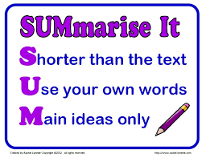  Question Focus: Summerise main ideas from more than one paragraph.  2c  Strategies:  - Carefully read the question, marking key words.  - Carefully read each paragraph separately, considering which statement applies to it (if appropriate).  Read all the other paragraphs to check you have given the best answer (if appropriate).
Question Focus: Identify/explain how information/narrative content is related and contributes to meaning as whole.  2f  Strategies:  - Carefully read the question, marking key words  - Carefully re-read the appropriate paragraphs and make notes (if appropriate).  - Look for text features and make notes (if appropriate). | 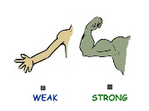  Question Focus: Identify/explain how meaning is enhanced through choice of words and phrases. Words have power.  2g  Strategies:  - Carefully read the question, marking key words.  - Consider where in the text to look for the words  - Carefully read the relevant section of the text while considering the impact of the words.
Question Focus: Making comparisons within the text  2h  Strategies:  - Carefully read the question, marking key words.  - Skim read the whole text, thinking about the question and make appropriate notes. | Question Focus: Retrieve and record information/identify key details from fiction and non-fiction  2b  Strategies:  - Carefully read the question, marking key words  - Consider where in the text you’ll find the answer.  - Scan the text for the information.  - Point, Evidence, Explain (if appropriate).
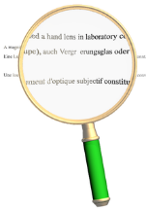  Question Focus: Making inferences from the text/explain and justify inferences with evidence from the text.  2d  Strategies:  - Carefully read the question, marking key words  - Consider where in the text to look for information.  - Carefully read that part of the text, and read between the lines.  - Point, Evidence and Explain (if appropriate). | 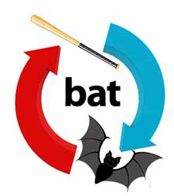  Question Focus: Give/explain the meaning of words in context.  2a  Strategies:  - Carefully read the question, marking key words.  - Scan the text for the sentence.  - Carefully read the sentence around this and understand the context.  - Match the options in the question to your understanding of the words – eliminate!

